Excel Help
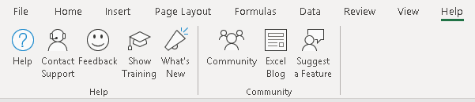
https://support.office.com/en-gb/excel
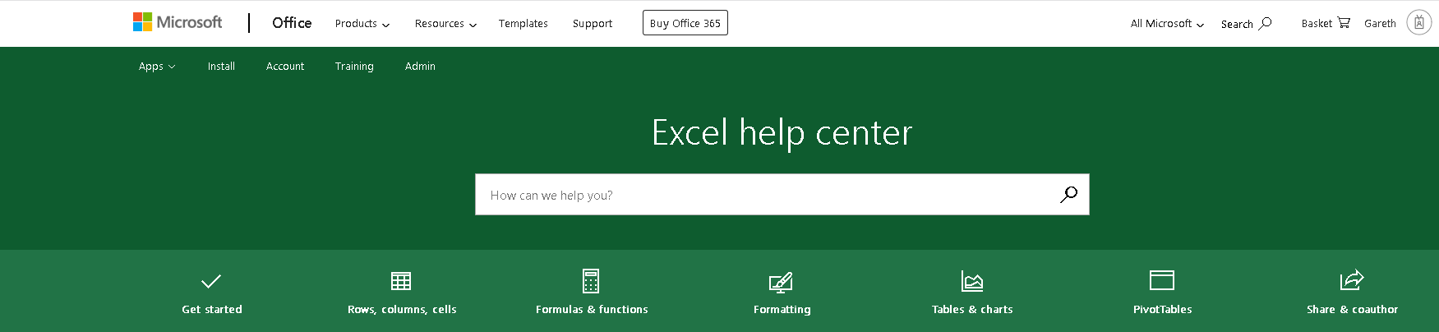
Excel Online (Free with a Microsoft Account) & Excel 365 (Included with a Office 365 Subscription)
Excel Online: https://office.live.com/start/excel.aspx
Excel 365: https://www.office.com/launch/excel?auth=2
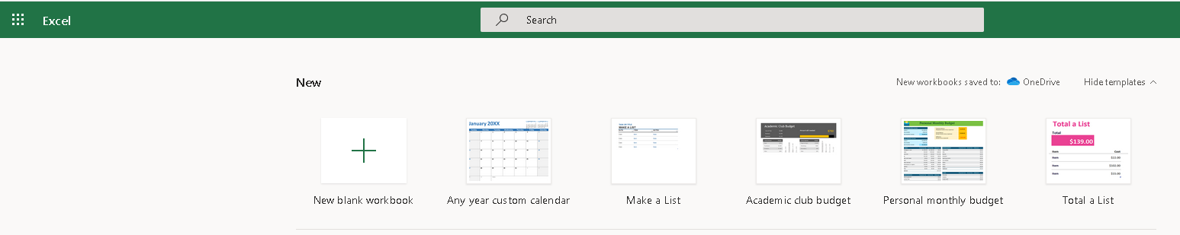
Excel Online & Excel 365 Help
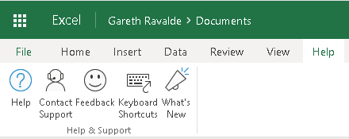
https://support.office.com/en-gb/excel

Google Sheets (free with a Google Account)
https://docs.google.com/spreadsheets/u/0/
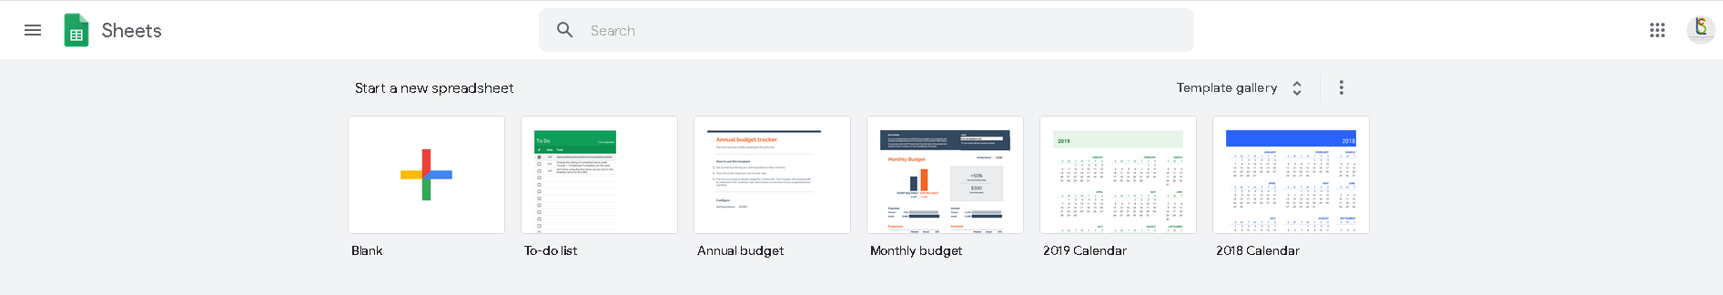
Google Docs Help
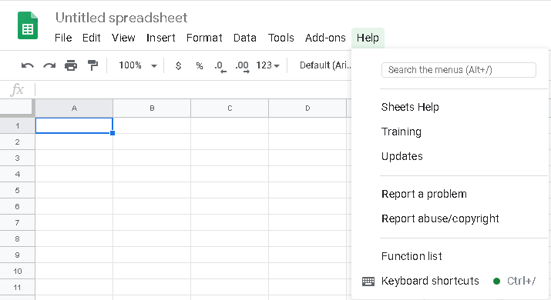
https://support.google.com/docs/topic/9054603?hl=en&ref_topic=1382883
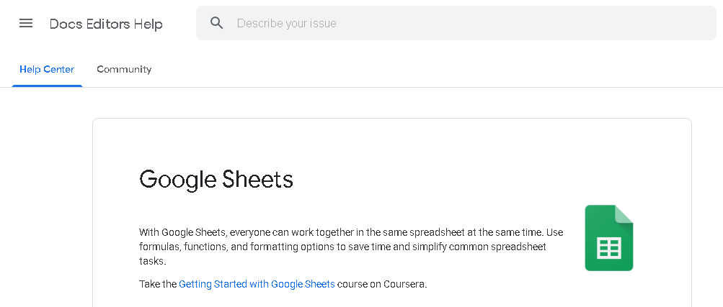

LibreOffice (Requires Install on Computer)
Download Link
https://www.libreoffice.org/download/download/

LibreOffice Help
Offline Help (Installed Separately)
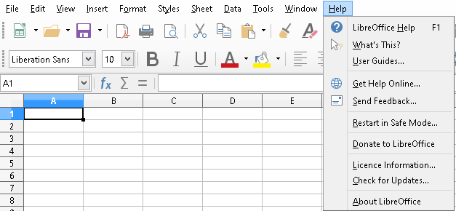
Online Help
https://help.libreoffice.org/6.1/en-GB/text/scalc/main0000.html?System=WIN&DbPAR=CALC
