POMODORO technique
What is it?
This is a cool time management method developed by Francesco Cirillo. The technique uses a 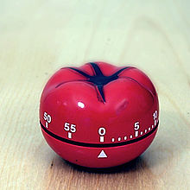to break down work into intervals, traditionally 25 minutes in length, separated by short breaks. These intervals are named pomodoros, the plural of the Italian word for tomato (after the tomato-shaped kitchen timer). The method is based on the idea that frequent breaks can improve attention. There are six stages in the technique:
- Decide on the task to be done.
- Set the pomodoro timer (traditionally to 25 minutes)
- Work on the task until the timer rings. If a distraction pops into your head, write it down, but immediately get back on task.
- After the timer rings, put a checkmark on a piece of paper
- If you have fewer than four checkmarks, take a short break (3–5 minutes), then go to step 1.
- After four pomodoros, take a longer break (15–30 minutes), reset your checkmark count to zero, then go to step 1.
Where to go: www.tomato-timer.com

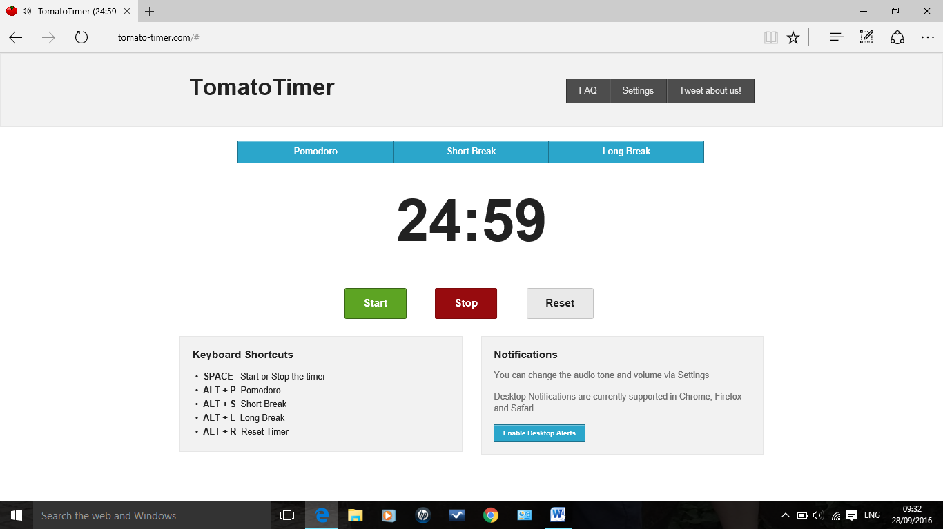

Or use YouTube video:
http://pomodorotechnique.com/

